|  |  |  |  |  |
| --- | --- | --- | --- | --- |
| EASY GRADE | | | | |
|  |  | | |  |
| COMPLETION PROGRESS | | | | |
|  | | Manual |  | |

TABLE OF CONTENTS

marking standards 3

how to access 4

how to grade 5

Progress column 6

Exception handling 8

# marking standards

Remember below color guide while marking

* Dark Green Box:Activity Completion / Compliance.
* Light Green Box: Activity submitted for marking.
* Dark Blue: Activity not completed, not started, not attempted
* Red: Activity not completed/ not compliance

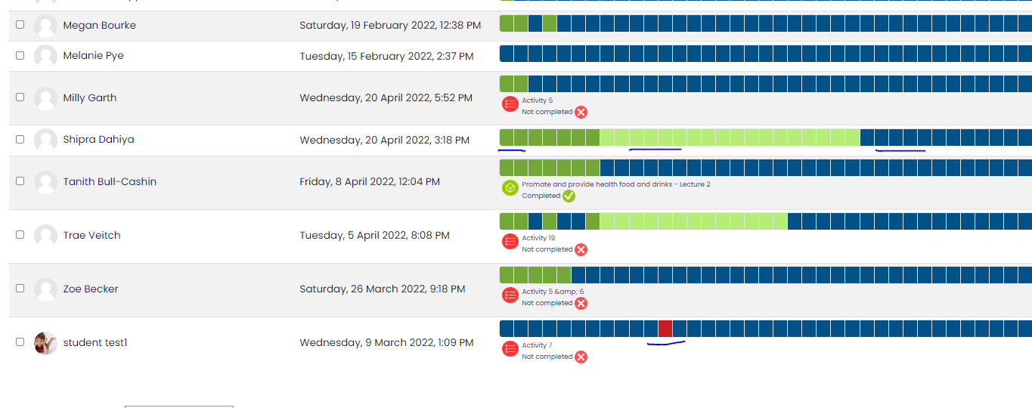

Note: GRADE could be 0(Zero) OR 1(One)

# how to access

Easy Grading development for completion progress

* Admin can check all students progress from right hand slider.
* Trainer can check their course all students progress from right hand slider.
* Student can check their course progress from right hand slider.

STEP 1 (SLIDER - RIGHT HAND SIDE IN CLUSTER):

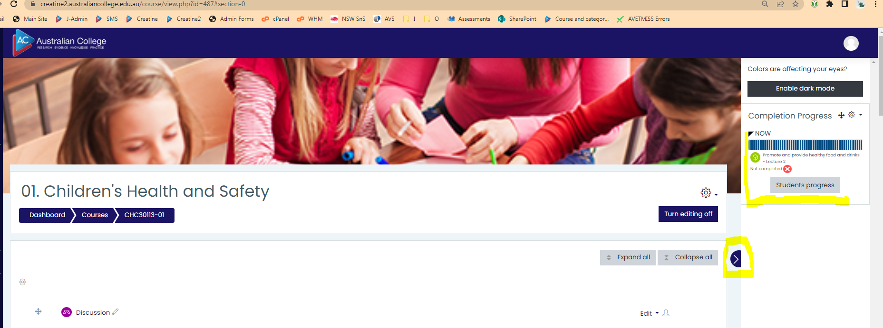

STEP 2 (ADMIN & TRAINNER VIEW):

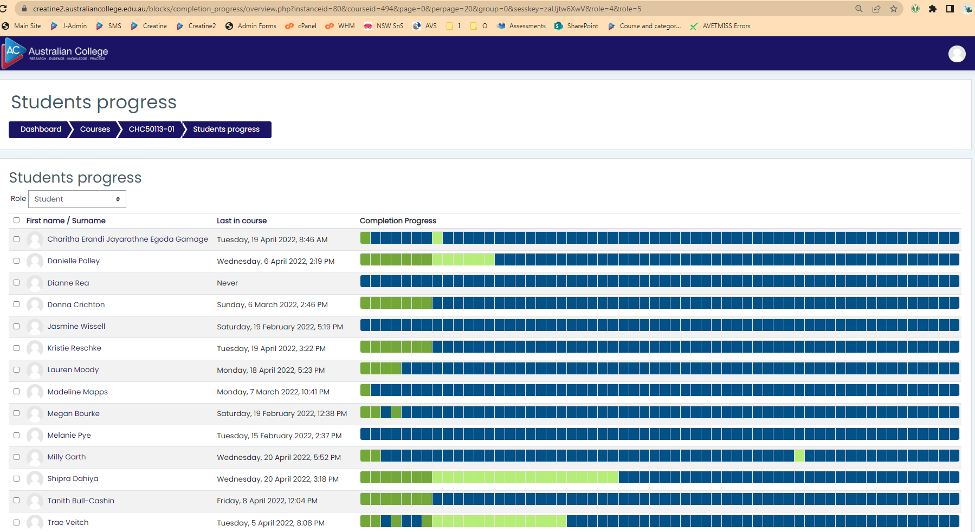

# how to grade

Highlight any activity to view activity name and status.

1. Click color bar to view activity in the same tab for grading.
2. Click on below activity name to view activity in new tab for grading. Recommended
3. Complete marking on new page (Mark, Save, Close page) Step 2

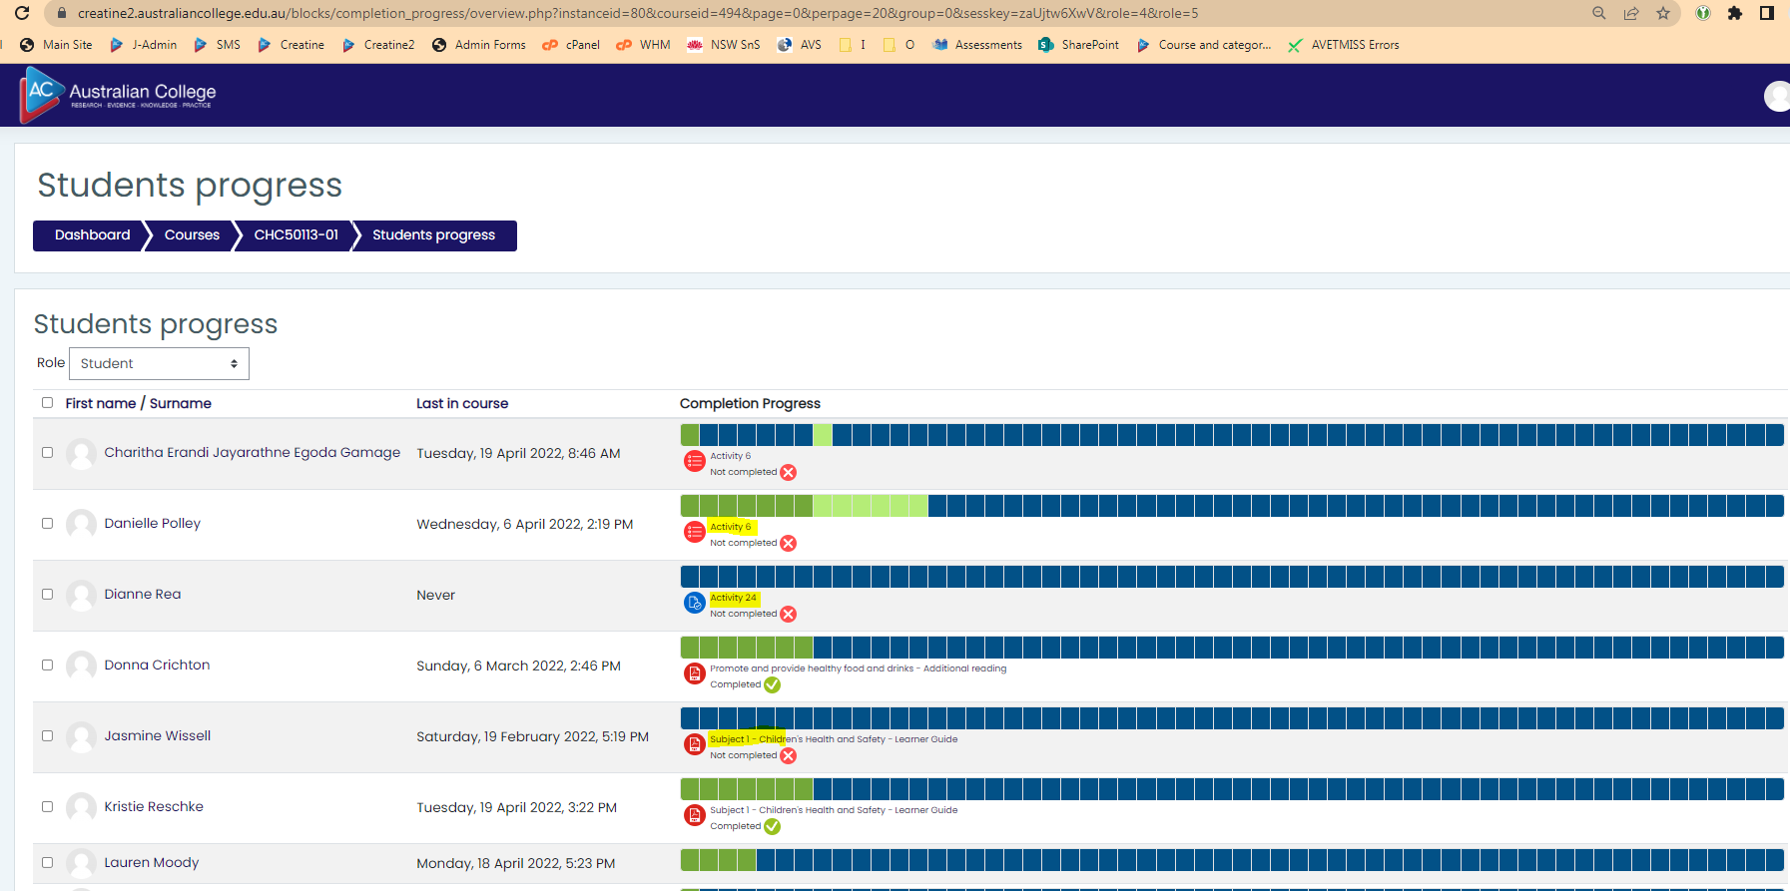

# Progress column

Before using the feature, please make sure below configuration.

1. All AC Staff /Course Manager role user will receive email notification about student 100 completion
2. All Trainer role user will receive email notification from AC Staff for grading process

Admin View:

1. If STUDENT completed 100% yesterday, “AC Staff” will receive email notification, “Student completed the assessment”
2. If STUDENT completed 100%, admin will see “Assign Trainer**”** button.

Assign Trainer: send an email to course trainer for start grading process.

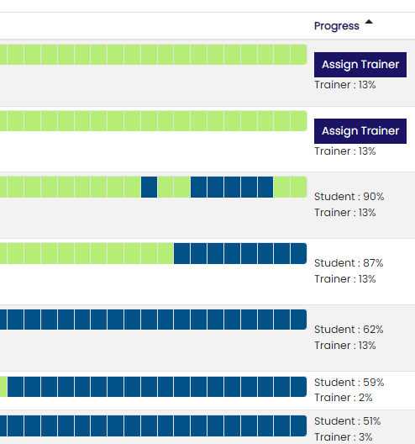

Trainer View:

1. If TRAINER/ Course Teacher completed 100% marking, “TRAINER” will see “Release result” button
2. Release result: button will send a notification to student for result release.

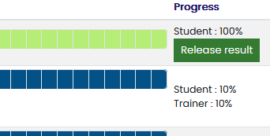

Student View:

1. If STUDENT completed 100%, status update: 100%, Please wait for result

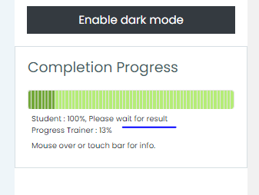

# Exception handling

Pages should ignore.

* Dark Blue: Activity not completed, not started, not attempted

1. Admin can view all student quiz/assignment submissions.
2. Trainer can view all student quiz/assignment submission.
3. Student can view a page to attempt quiz/assignment.

Ignore below pages while grading.

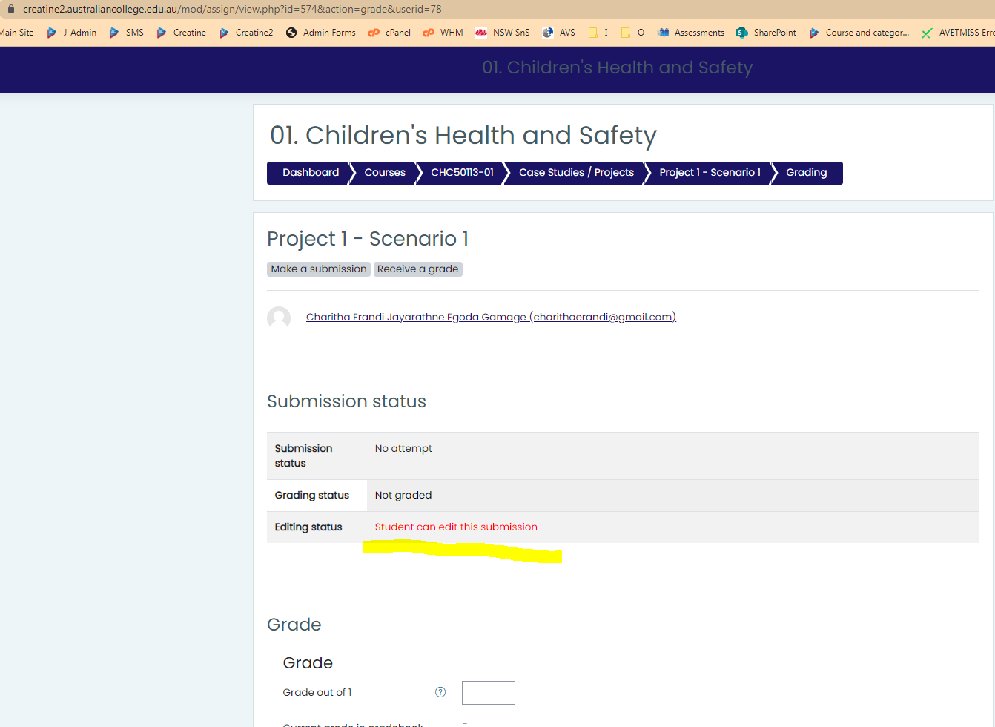

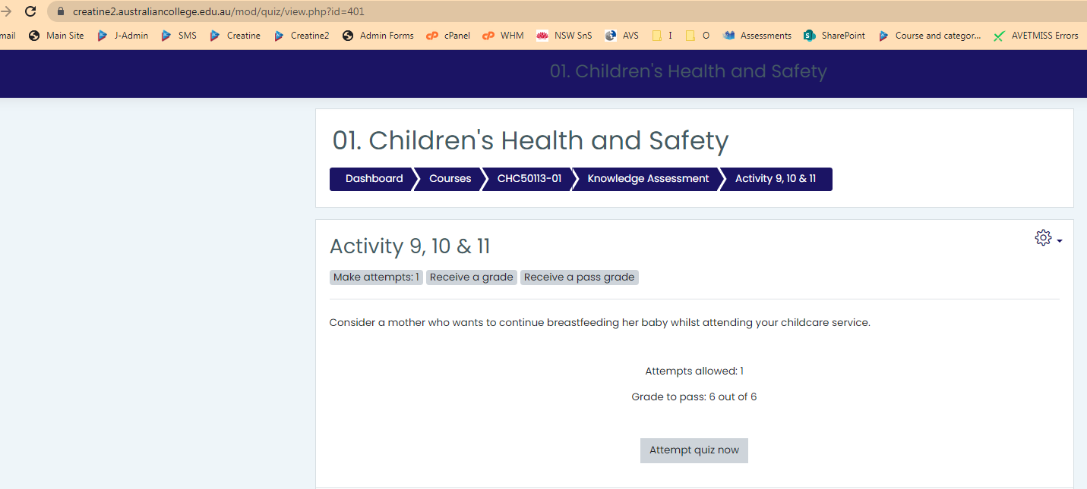

THANK YOU

Should you have any questions, please do not hesitate to contact IT department:

**Syed Nayab Bukhari**

[Syed@australiancollege.edu.au](mailto:Syed@australiancollege.edu.au)

[Bec_dir@yahoo.com](mailto:Bec_dir@yahoo.com)